**Script Development Requirements**

**Summary**

The requirement is to create multiple scripts that will perform different tasks in a multi-stage file parsing process. The scripts can be shell scripts of other any other scripts preferably to be run in a Windows environment for easier file management. The scripts will be run against .csv files that are exported from Cisco ISE and some scripts will need to be imported back into Cisco ISE so the format of the .csv file result is important.

The summary of the requirements are as follows:

* 30 Day Authentication Database - Multiple files (possibly a single file in some situations), one file for each network switch, with 30 Days of authentications will be exported from Cisco ISE.
* The files (30 Day Authentication Database) will be parsed, and duplicates removed keeping the most recent entry by date and stored into a single file.
* Endpoint Database - Multiple files (possibly a single file in some situations), one file for each network switch, with active Endpoints will be exported from Cisco ISE.
* The files (Endpoint Database) will be parsed, and duplicates removed and stored into a single file.
* At this point the result for this run will be two files, “Endpoint Database Combined” and “30 Day Authentication Database”.
* Compare the “30 Day Authentication Database” against the “Endpoint Database Combined” and for any MAC address that is not in the “Endpoint Database Combined” file a record will be created using attributes from the “30 Day Authentication Database” file.

**This “Endpoint Database Combined” file must maintain file structure from the original files that were exported.

**Solution Requirement Details**

This solution requirement details will be provided in this section and includes that following.

**Step 1** – Extract one or more .csv files (30 Day Authentication Database) from Cisco ISE.

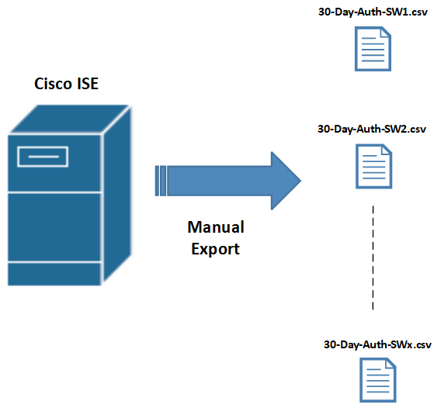

The “30 Day Authentication Database” .csv file format is shown below.

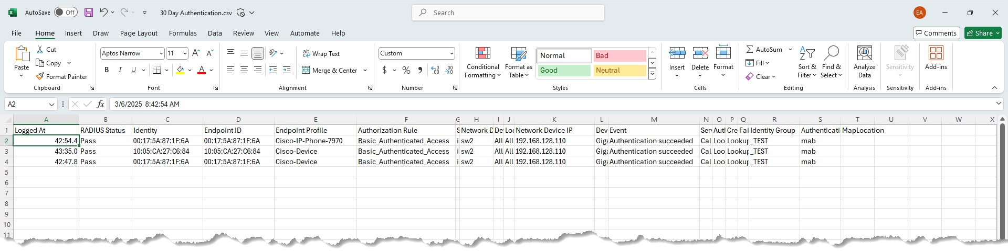

**Step 2** – Parse the “30 Day Authentication Database” .csv files removing duplicates.

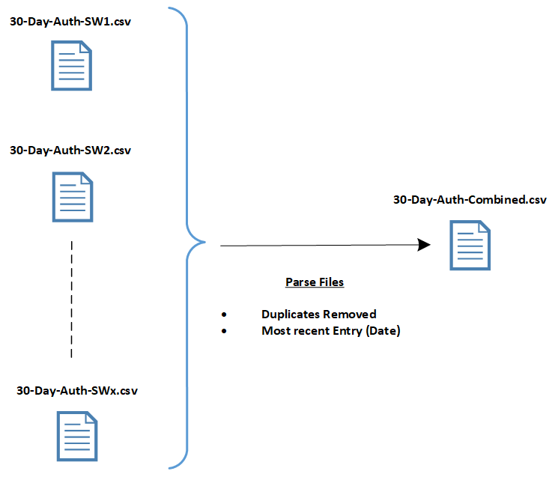

**Step 3** – Extract one or more .csv files (Endpoint Database) from Cisco ISE.

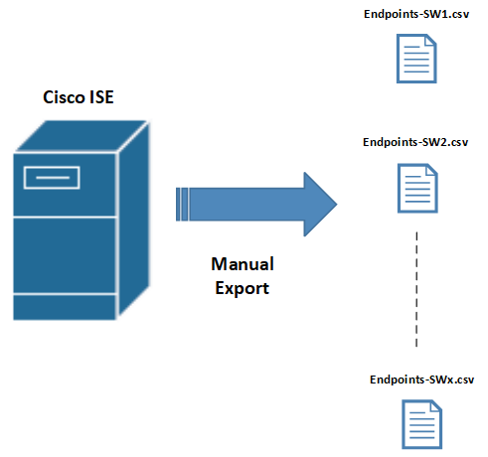

The “Endpoint Database” .csv file format is shown below.



**Step 4** – Parse the “Endpoints Database” .csv files removing duplicates.

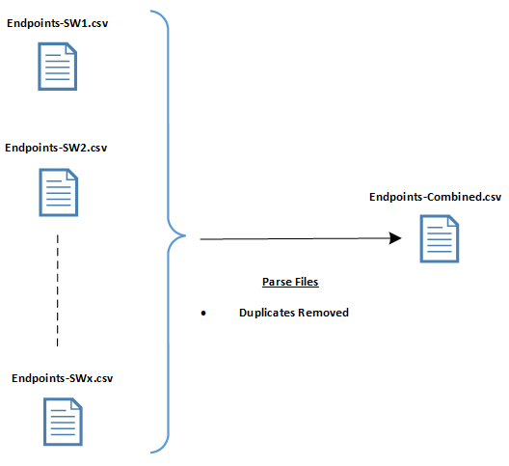

**Step 5** – Compare the “Combined Endpoints Database” .csv file and “Combined 30 Day Authentication Database” .csv file. If an endpoint MAC address entry is in the “Combined 30 Day Authentication Database” .csv file but NOT in the combined “Endpoints Database” .csv file add the endpoint MAC address entry to the “Combined Endpoints Database” .csv using the field mapping table provided (making sure the original file format is not altered).

| **Combined 30 Day Auth Database Field** | **Data**  **Value** | **Maps to** | **Combined Endpoint**  **Database Field** | **Data**  **Value** |
| --- | --- | --- | --- | --- |
| Endpoint ID | Existing Value | **-->** | MACAddress | From Mapping |
| Identity | Existing Value | **-->** | User-Name | From Mapping |
| Endpoint Profile | Existing Value | **-->** | EndPointPolicy | From Mapping |
| Device Type | Existing Value | **-->** | Device Type | From Mapping |
| Location | Existing Value | **-->** | Location | From Mapping |
| Identity Group | Existing Value | **-->** | IdentityGroup | From Mapping |
| N/A | N/A | **-->** | DeviceRegistrationStatus | NotRegistered |
| N/A | N/A | **-->** | BYODRegistration | Unknown |
| N/A | N/A | **-->** | StaticAssignment | FALSE |
| N/A | N/A | **-->** | StaticGroupAssignment | FALSE |
|  |  |  |  |  |